Project Design Phase-I - Solution Fit Template
Focus on J&P, tap into BE, understand RC

Date | 3 February 2026
Team ID | LTVIP2026TMIDS87719
Project Name | Heart Disease Analysis Using Tableau
Maximum Marks | 4 Marks

Problem - Solution Fit

The Problem-Solution Fit phase ensures that the identified healthcare challenges are effectively addressed by the proposed solution.
In this project, the major challenge was analyzing large-scale heart disease datasets involving patient demographics, medical history, lifestyle choices,
and clinical indicators. To overcome this, an interactive Tableau dashboard was designed to provide clear visual insights, dynamic filtering options, and
storytelling dashboards. The solution directly aligns with user needs by simplifying data interpretation, highlighting risk factors, and improving
preventive decision-making efficiency.

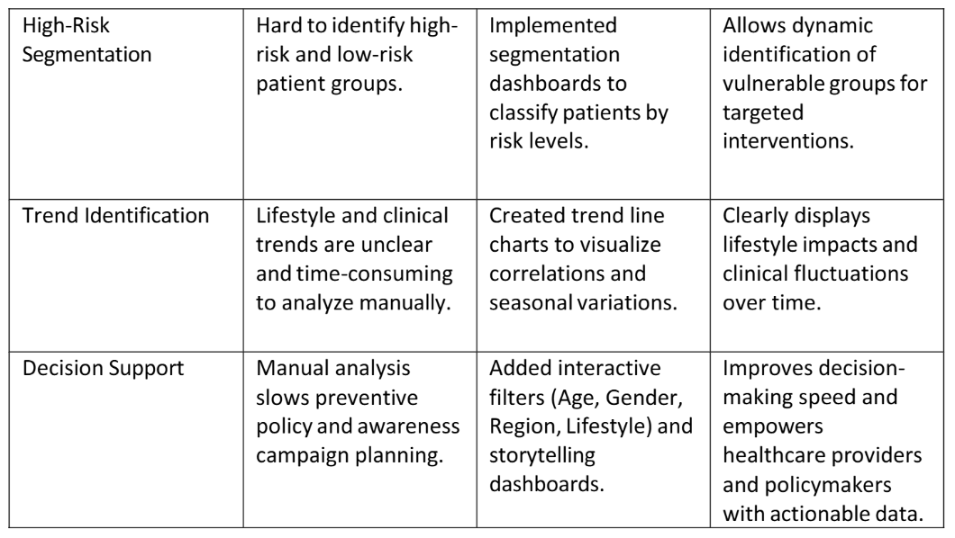

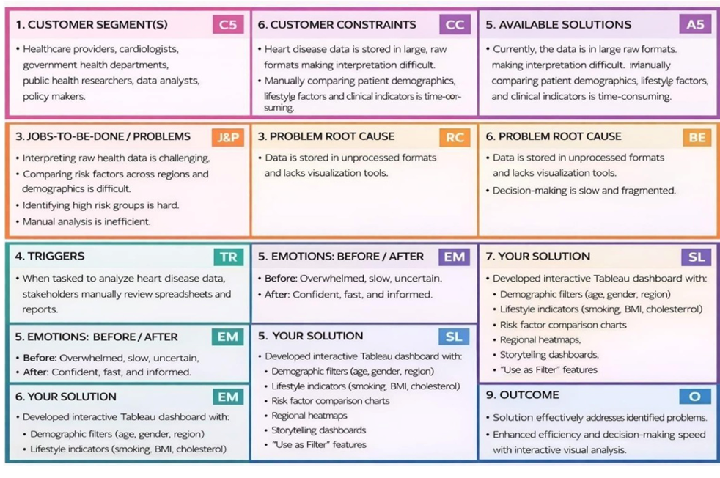

Explore AS, differentiate
Deﬁne CS, ﬁt into CC

